

***Report of the Research Summer School for Glasgow College UESTC (2019-20)***

Name：Haoyu Liu

UoG Number: 2429428L

Grade: Sophomore

Project: Deep Learning Enabled Real-time Object Detection on a Live Video Stream

**Abstract:**

*This report is for the project (Deep Learning Enabled Real-time Object Detection on a Live Video Stream) which I participate in during the research summer school for Glasgow College UESTC (2019-20). The major algorithm in this project is YOLO (You Only Look Once) which is famous for its relatively high speed for detection and better accuracy compared to other object detector algorithms. I would apply it in my project to achieve the objectives—develop the object detector based on YOLO to detect the objects from a live video stream. Thus, the priority is to understand the YOLO algorithm about its mechanism (network architecture, theorem), advantages and limitation which I would illustrate in the report along with my experiments. I got good results and bad results during the process of experiment, allowing me to compare the performance of YOLOv3 and YOLOv4 which I employed. The analysis would be generated about the difference of these two algorithms. Find out the limitation of the work I have done and think about the solution to improve my results, partially improve the performance of the YOLO algorithm. Plus, expect the future work could be involved to enrich my understanding of YOLO and other image recognition algorithms so that I might do some further research in the field of computer vision and image recognition.*

1. Introduction

Background

YOLO (You Only Look Once) is one of the most powerful real time object detector algorithms that needs images or video to pass one time through its network. The algorithm implements three major functions—image classification, object localization, and object detection—based on regression instead of classification. To achieve this, YOLO uses a unique neural network (Darknet), employing the characteristics of the entire image to predict multiple boxes, each containing the particular object. In that case, it produces all of the bounding boxes and class probabilities simultaneously. To be more specific, an image would be divided into $'S'×'S'$ region. Then if the center of an object is in one of these regions, the region in question is responsible for detecting the object. Each of the cells in this grid is responsible for predicting bounding boxes all containing an object as well as a score representing the level of confidence for the object present in the box. If there are no objects in the cell, this score should be zero, otherwise, if an object is in the cell, the score will be equal to the intersection over union (IoU) between the predicted box and ground truth of the image. In the next phase, the class-specific confidence scores for each box would be done by using the Darknet which is an open source neural network framework written in C and CUDA. The output for this algorithm would be the image (or video), sent as the input, with the objects localized and the class attached to it. [1]

As previously discussed, YOLO reasons at the level of the overall picture, rather than examining successively several regions. Though this allows a huge increase in detection speed but causes a small decrease in the accuracy of object detection compared to the other detection compared to the other detection methods. YOLO is actually one of the most powerful and used object algorithm right now in multiple fields like autonomous vehicles poker cheat detection and more.

Objectives

This project aims to develop a real-time object detection system that could recognize objects from a live video stream. Real-time object recognition models should be able to sense the environment, parse the scene and react accordingly. The model should be able to identify the types of objects in the scene. Once the type of objects has been identified, the model should locate the position of these objects by defining a bounding box around each object. Based on the YOLO algorithm, I gained an insight into the algorithm and applied it online (Google colab) and offline (laptop) to recognize the goal—detect single or multiple objects from images and videos. With a general understanding of deep learning, I completed this research and recognized its goal using Python.

There are basically three stages of this project: to begin with, develop the practice skills of how to program in Python Programming Language with installing related software and building a deep learning environment, then learn some vital and relevant python libraries from online tutorial and recommended reference books. After a quick intro to fundamentals of machine learning algorithm, develop a basic understanding of YOLO algorithm for object detection. Last but not least, I would perform live object detection applying this algorithm and evaluate the analysis of the performance of YOLO.

1. Literature review

Just like the phrase “What-you-see-is-what-you-get” says, human brains make vision easy. However, it is hard for a computer to imitate. Image recognition is a subcategory of Computer Vision and Artificial Intelligence, representing a set of methods for detecting and analysing images to enable the automation of a specific task. Generally, the modelling process for this technology could be divided into four steps: extract pixel features from an image; prepare labelled images to train the model; Train the model to be able to categorize images; recognize (or predict) a new image to be one of the categories. Moreover, convolutional neural networks (CNN) have been widely applied in image classification, object detection or image recognition.

YOLO algorithm is a category of image recognition method which has been updated for better accuracy and higher speed along since the first publication of *You Only Look Once: Unified, Real-Time Object Detection.* This paper guided me into the field of computer vision and deep learning. For the previous methods, such as R-CNN, they usually first generate around two thousand region proposals, followed by computing CNN features and classifying regions. With the mode of two steps of detection, they are much slow compared to YOLO. Because YOLO has unified network to perform the two stages as once with end-to-end training network. [7]

In YOLOv1, input image is divided into $7×7$ grid and each grid cell would predict 2 bounding boxes and their confidence scores which reflect how confident the model is that the box contains an object. Plus, each of the bounding boxes consists of totally 5 predictions x,y,w,h and confidence. The center of the box relative to the bounds of the grid cell would be represented as the (x,y) coordinates, in terms of the whole image, the width w and height h are necessary. The confidence represents the Intersection Over Union (IoU) between the predicted box and any ground truth. The width w and height h are predicted relative to the whole image. The confidence represents the IoU between the predicted box and any ground truth box. Moreover, grid cell predicts conditional class probabilities (total number of classes=20), for instance, P(Cat|Object). Thus, the output size of YOLO is $7×7×\left(2×5+20\right)=147.$ [1]

The YOLO model network architecture consists of a total of 24 convolutional layers: First 20 convolutional layers followed by an average pooling layer and a fully connected layer is pre-trained on the ImageNet 1000-class classification dataset with resolution $224 x 224$. Last 4 convolutional layers followed by 2 fully connected layers are added to train the network for object detection which requires more granular detail, so the resolution of the dataset is bumped to $448 x 448$. The final layer predicts the class probabilities and bounding boxes. In brief, the input is a $448 x 448$ image and output is the class prediction of the target enclosed in the bounding boxes.

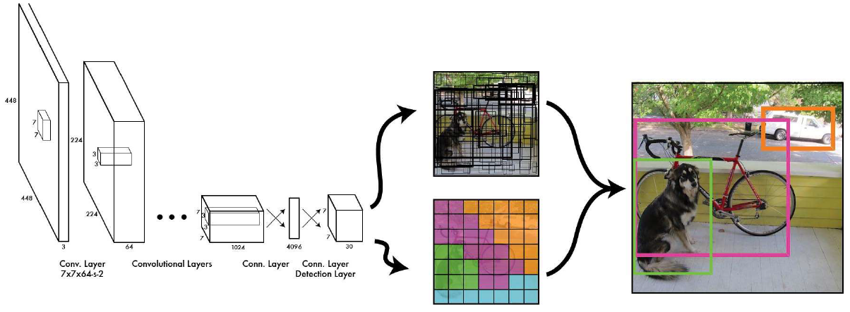

Figure whole network pipiline

Another import part is the five terms of loss function.

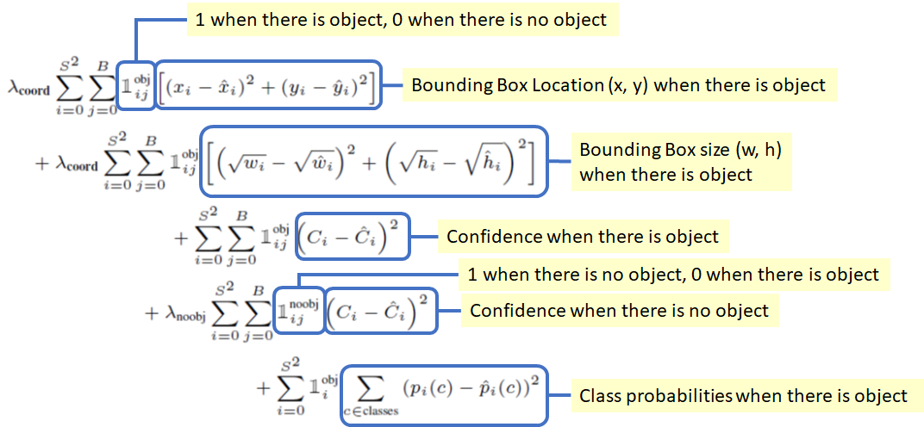

Figure Loss function

However, YOLOv1 makes many localization errors with relatively low recall compared to region proposal-based methods. The enhancement in YOLOv2would mainly focus on improving recall and localization and use Darknet-19 as feature extractor, here are the improvements:

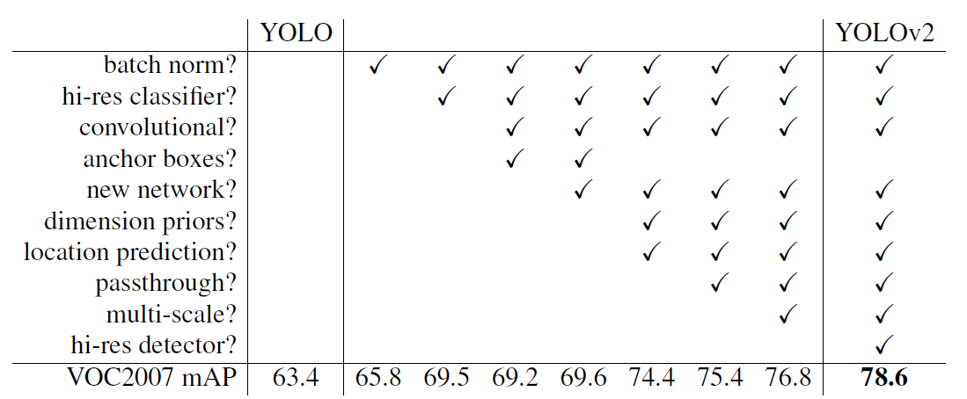

Figure Incremental improvements

Yolov2 runs faster than YOLOv1but with less accuracy on smaller batches and slower but more accurately on larger batches.As for YOLOv3, the bounding box prediction is as same as YOLOv2, but it uses independent logistic classifiers and binary cross-entropy loss instead of softmax because of overlapping labels for multilabel classification. Due to the prediction across scales and feature extractor Darknet-53 allow us to get more meaningful semantic information from the upsampled features and finer-grained information.[2]

After I learned the basic knowledge of YOLO, I could understand the mechanism of this algorithm and admire the authors’ contribution to this technology. In my project, I employed YOLOv3 and YOLOv4 to detect object in images and videos of single or multiple classes. YOLOv4 is an updated version of YOLO, its model training could be done on a single GPU. Bag-of-Freebies and Bag-Of-Specials would improve the network. Especially, its backbone could be the same one as YOLOv3. Without the knowledge of YOLO, I might not continue my experiments and analyze the performance of my results as well as compare YOLO with other algorithms.[3][4]

1. Methodology

According to the basic knowledge introduced previously, the target of the project is to detect the objects in the live stream. In the first place, I need to know how to generate the YOLO algorithm and the neural network (Darknet) to achieve the goal. Therefore, I began with the images as the inputs by using YOLOv3 because this algorithm would cater for my needs, its speed of prediction of the object is fast enough during the detection in live stream or videos and the accuracy is higher than the YOLO and YOLOv2. Moreover, this classic algorithm would help me be capable to understand the function of important codes, such as how to predict bounding box, enabling me to gain more insight into the YOLO.

After I installed the Anaconda, I needed to build the environment to generate the YOLO algorithm and neural network, I downloaded Pytorch, OpenCV, Git and imported related libraries in case that I would use them during the process. Then I started implemented YOLOv3 on my laptop: I clone the darknet from github(<https://github.com/alexeyab/darknet>) from my command prompt it would create the repository for me automatically. After that, I use Visual Studio to build the whole project and create the darknet executable. Go back to the command prompt, run all the convolutional layers to detect the objects, the output is an image saved as png with objects enclosed in the bounding boxes and with its classes as a label. Besides, the confidence scores are 99% for bicycle, 100% for dog and 94% for truck. Similarly, I use YOLOv3 to perform the detection of a video by generating the pre-trained dataset (coco dataset).

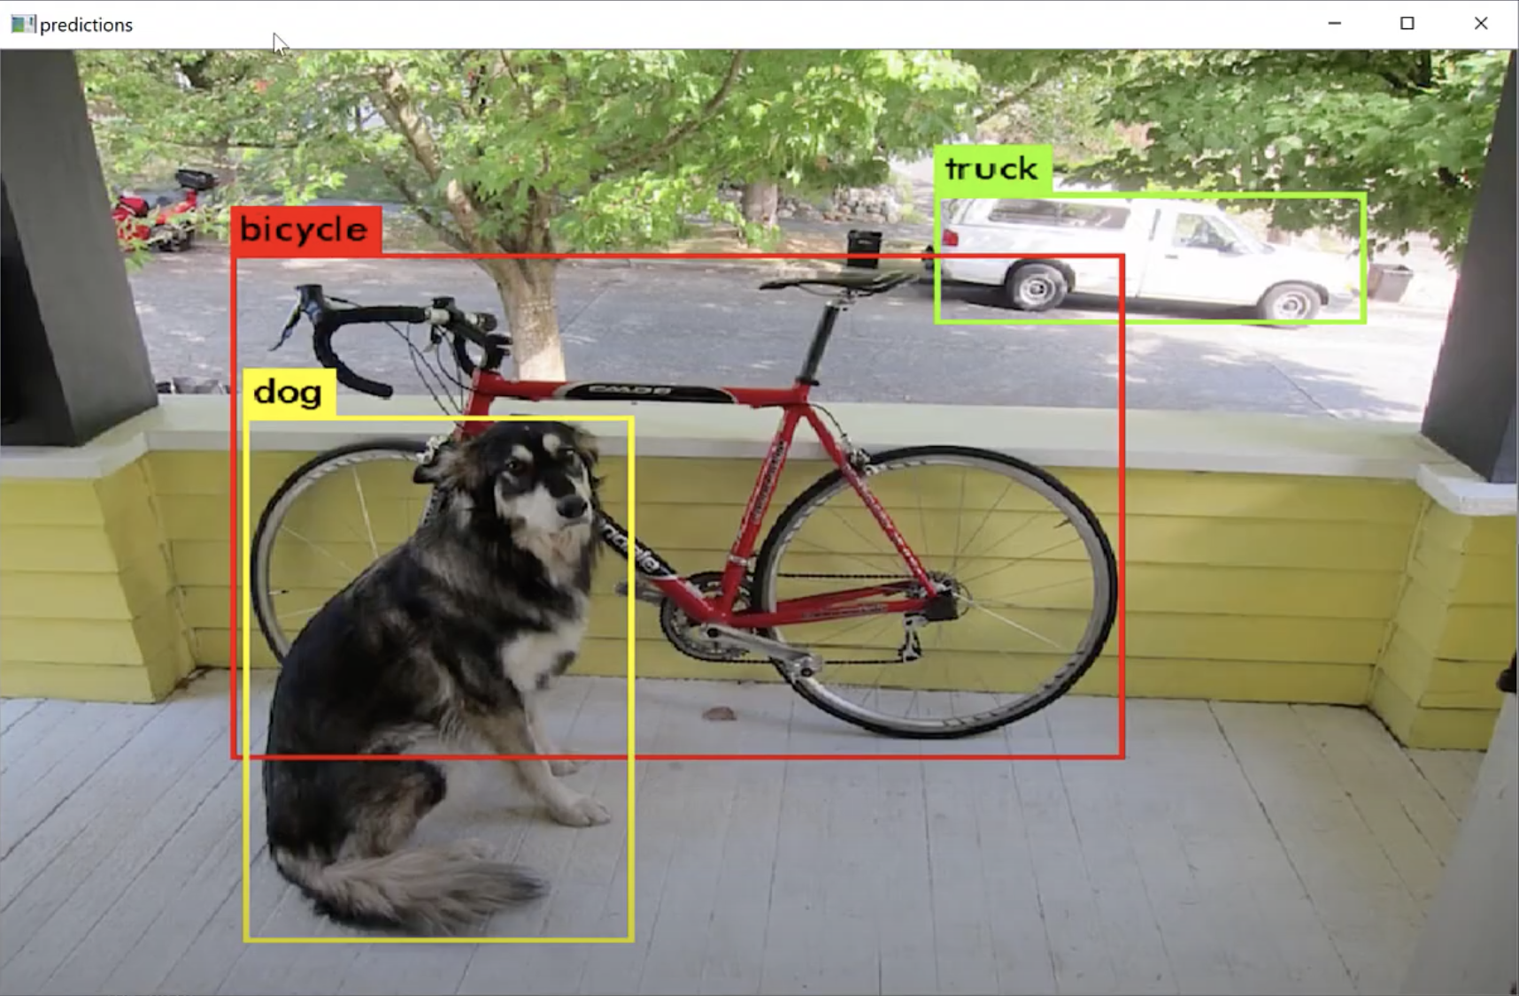

Figure Prediction

In the next phase, I would customize my own object detector which could detect single or multiple classes. I downloaded the pre-trained dataset (Google open images) by employing a practical toolkit called OIDv4_Toolkit (<https://github.com/EscVM/OIDv4_ToolKit>). I chose specific classes—Ballon and Airplane—to be my targets in the object detector. Firstly，use commands in the shell to download the necessary files for training, such the pictures and related annotations. Then I download images from image-level labels dataset for image classification so that I could generate the sub-dataset between human-verified labels h and machine-generated labels m，followed by generating .txt annotation files in proper format for custom object detection with YOLOv3. The text files are settled in folder with images. Until now, I have my own dataset for detecting the balloon and airplane. The next thing to is utilize my new dataset to train the neural network and predict the object I wanted. Another important thing is to create yolo-obj.cfg with the same content as in yolov3 and change some values in order to fit the need of my training, otherwise, the speed and performance might be unsatisfactory.

The next step is to input my own images to test the detector. It did work and output the results:

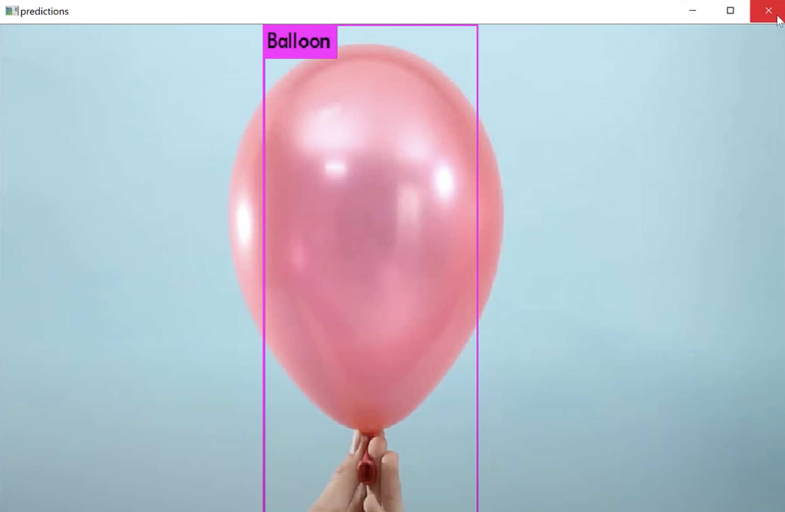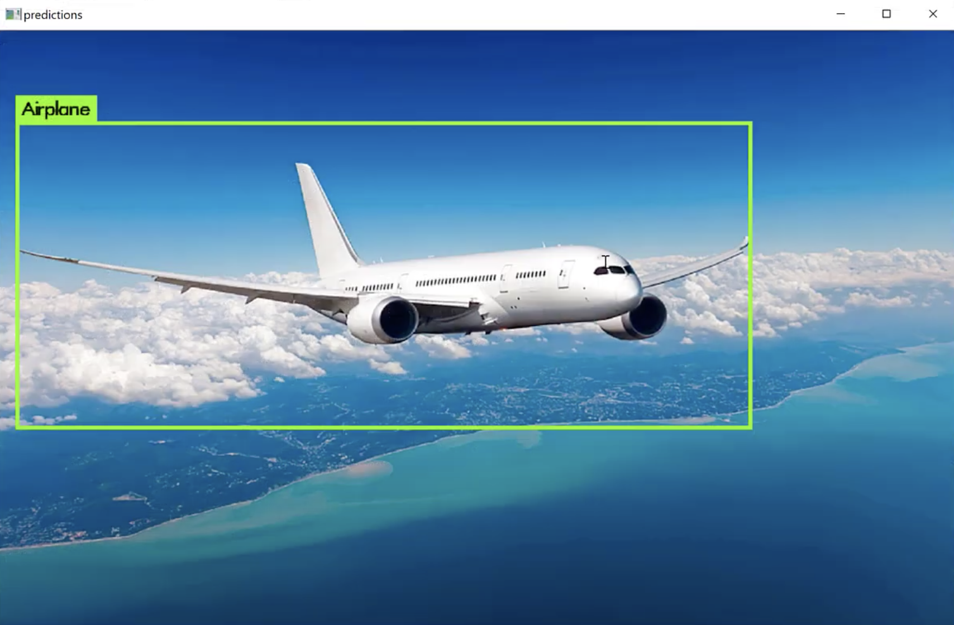

Figure Multiple Classes detection

So far, I was able to use the object detector generated by YOLOv3 to predict the target in images and videos, especially cater for my requirements (specific classes). Since I have done the detection on my laptop without GPU, the speed for the training is slow and the time for the detection would be much longer than the process generated on GPU. Thus, I turned to the Google Colab which is a python development environment that runs in the browser using Google Cloud and it is easy to use the GPU provided by Google for free. Plus, the YOLOv4 has better persormance on detection which beating the fastest and most accurate detectors in terms of both speed and accuracy and its the AP and FPS have increased by 10 percent and 12 percent, respectively. I was interested in this algorithm and tried to applied it on Jupyter notebook using python, enabling me to train the darknet and experience the process based on GPU.

Firstly, I needed to follow the sequence of how to consturct a YOLOv4 object detector. After enabling GPU within the notebook (100times faster than CPU), it is of necessity to clone and build Darknet by cloning from Github (<https://github.com/AlexeyAB/darknet>). Next, YOLOv4 has been trained already on the coco dataset which has 80 classes that it can predict. I would grab these pretrained weights from Github so that we can run YOLOv4 on these pretrained classes and get detections. Generata helper functions in order to show the image in my Colab Notebook after running my detections, as well as upload and download images to and from my Cloud VM. Then I could run my detections with Darknet and YOLOv4, the input could be uploaded from local or Google Drive. And the results (image or video) could be shown in the Colab Notebook or saved to local or Google Drive. I would like to train my own YOLOv4 custom object detector recognize any classes or objects I want in the next phase. The first thing is to gather and label a custom dataset, I chose Google open images as my resource for it has enough images and labels to use. I used the same toolkit (OIDv4 Toolkit) as in the YOLOv3 algorithm to download the pictures for me to train our custom object detector. Besides, I had a validation dataset in order to properly test our custom object detector after it was trained. It is vital to convert the label to the YOLOv4 format, otherwise, the traing would fail. Also, I could manually label the images with annotations tool, but it woud take much time due to lack of efficiency. After I have my custom dataset, I moved them on my cloud VM so that I could use them later. I would configure files for training，changing some values about the Darknet so that it would fit my single class detection. Download the weights for the convolutional layers of the YOLOv4 network. By using these weights it helped my custom object detector to be way more accurate and not have to train as long. Then, I let the Colab Cloud Service do the training. At last, I put an input image to test my object detector, here is the result:

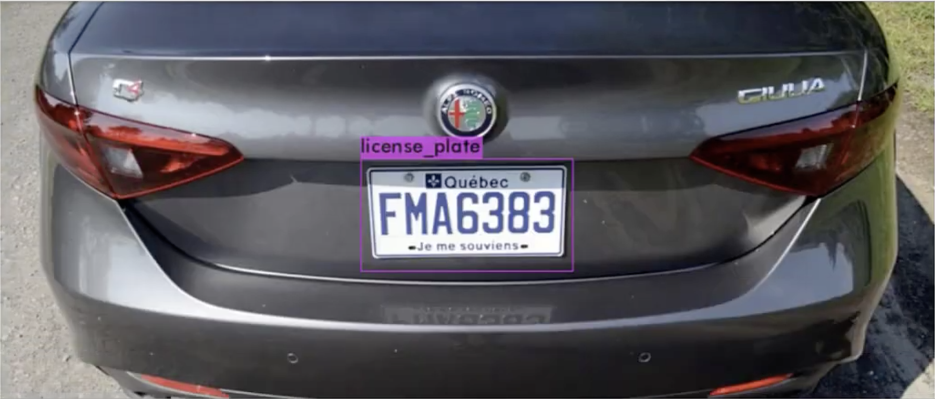

Figure Output of single class detector

1. Results

Actually, not all the process is successfully worked. I have got not only the best results, but also the worst ones. Hence, in this part, I would illustrate them both and analyze their performance. Besides, I would point out the limitation of my work and the progress I have made.

Experiments and Analysis

At first, I used the YOLOv2 to do the experiments, but I did not get satisfied results. When the input was videos, the value of the frame per second of the output would be about 10. Meanwhile, there were many relatively small objects would not be detected, though the objects could have been detected since their classes’ images were used for training before detection. Moreover, according to my observation, sometimes the labels of the objects would not be correct. Based on my analysis, the reason for the occurrence of these problems might be the backbone (Darknet-19) and my laptop. Compared to YOLOv3, though both algorithms use Batch Normalization, Darknet-53 uses shortcut connections. And 1000-class ImageNet Top-1 and Top5 error rates are measured as the following:[5]

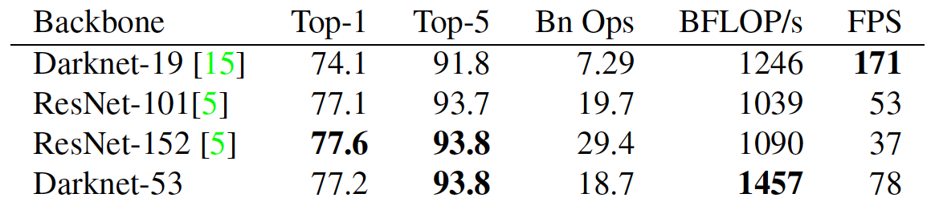

Figure 1000-Class ImageNet Comparison

According to the relevant paper, the frame per second could reach almost 100 with GPU when the resolution of the video is not too high. Hence, for the low fps, the input video’s resolution is too high to detect as quick as shown in paper and my laptop executes with CPU instead of GPU. For the average precision, the Darknet-53 has much better performance than the Darknet-19 as shown below:

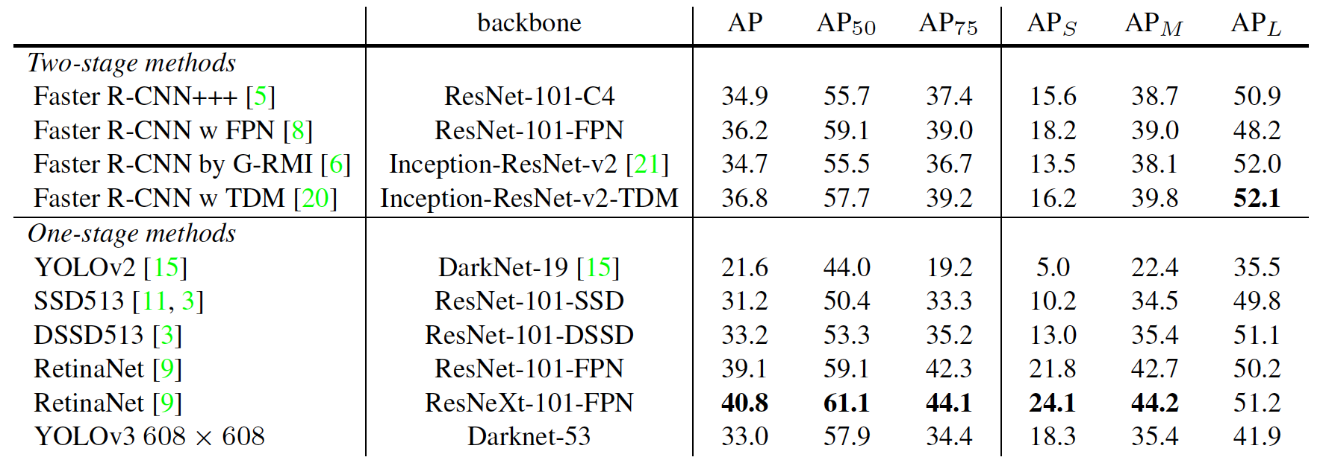

Figure Average precision of different algorithms

After this experiment, I started to apply YOLOv3 and YOLOv4. And the best result I got would be with YOLOv4. I uploaded my own dataset about Vehicle License Plate to Google Colab, then train my object detector within 7 seconds using weights, the mean average precision of it (88.57%) would be shown below:

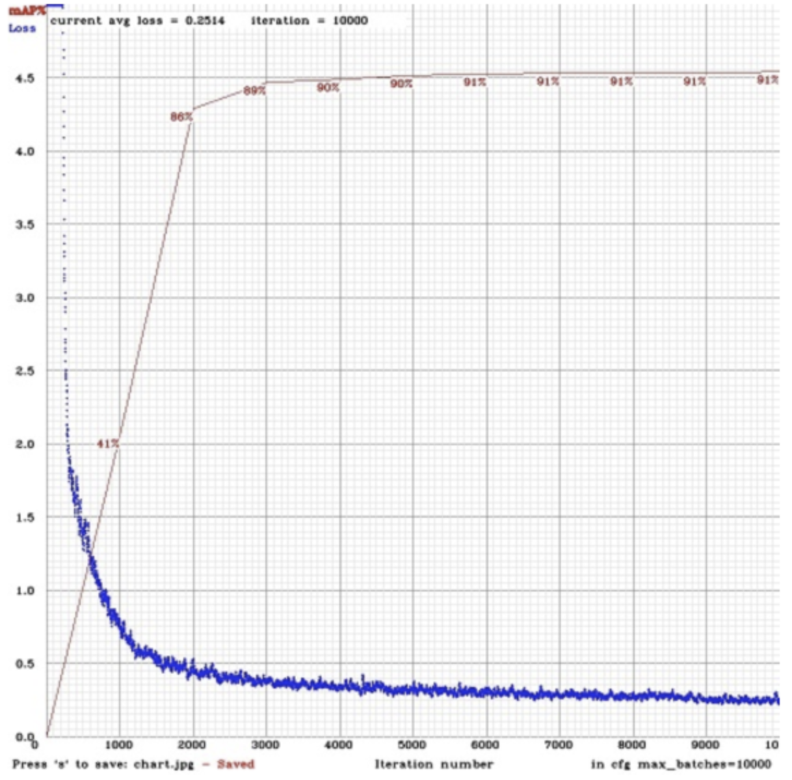

Figure mean average precision

Predicted in 33.186 milli-second, I had my results with confidence score of 98%, and for the videos, the fps was about 25 which approximately reached the video setting. So, the GPU did improve the speed. Besides, the YOLOv4 itself could handle more frame per second with high average precision compared to YOLOv3 as shown below:

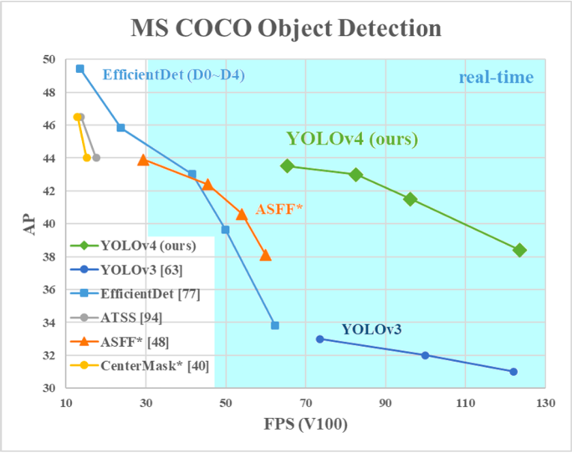

Figure Performance of YOLOv4

Limitation

Though I got satisfied results using YOLOv4 to detect objects in videos, some tiny objects would still be lost and the dataset for the training should contain enough images, otherwise the precision would be influenced.

Progress

To improve the performance of my object detector, I needed to use more images and related labels to enrich my dataset so that the precision would be guaranteed. I tried to enhance the YOLO algorithm by using K-means++ clustering method to get anchor box instead of K-means clustering method. In that case, the anchor box would be more fit the object which could increase the mean average precision.

1. Conclusions and future work

Conclusions

During the whole summer school, I basically understand the theory of image recognition, especially the YOLO algorithm. I gained an insight into the different version of this algorithm anread the relevant paper, allowing me to compare their performance. Besides, I followed the tutorial online to generate my own object detector based on YOLOv3 and YOLOv4. I managed to detect single or multiple classes of targets by create my own dataset. After the experiments, I did a general analysis on the performance of my results and the algorithms I chose to use, and provided the methods that might improve the performance of the object detector.

Future work

In the future, I would continue to research in Computer Vision and Pattern Recognition. For instance, do more research in the image recognition algorithm, including YOLO, Faster R-CNN, SSD and so on. To know these algorithms better, I would read more relevant paper to compare their different methods to achieve the same goal—detect object. As for the Faster R-CNN, RPN network is to pre-check which location contains object so that the corresponding locations and bounding boxes will pass to detection network which is similar to Fast R-CNN. Also, I need to understand the 4-Step Alternating Training for training procedure and ablation study. As for the SSD, we only need to take one single shot to detect multiple objects within the image which is faster compared with two-shot RPN-based approaches. I need to how the multibox detector works and its unique SSD network architecture. Compare their different loss function and try to understand the mechanism of them. For SSD, the scales and aspect ratios of default boxes are essential. Last but not least, YOLO, which I have worked on for almost a month, is an efficient algorithm with its feature extractor (Darknet). The majority would be compared their performance on detecting distinguish dataset so that I could conclude their advantages and disadvantages by doing experiments online or offline and gathering results.

Based on the understanding of YOLOv3, I want to explore more methods to improve the performance of YOLO in practice. If it is possible, I may construct new network architecture to detect tiny object with high accuracy and speed and this new technology might help surgeon to perform operation precisely or in other fields. And I believe the technology would make a world a better place.

**References:**

[1] J. Redmon, S. Divvala, R. Girshick and A. Farhadi, "You Only Look Once: Unified, Real-Time Object Detection," 2016 IEEE Conference on Computer Vision and Pattern Recognition (CVPR), Las Vegas, NV, 2016, pp. 779-788, doi: 10.1109/CVPR.2016.91.

[2] J. Redmon and A. Farhadi, "YOLO9000: Better, Faster, Stronger," 2017 IEEE Conference on Computer Vision and Pattern Recognition (CVPR), Honolulu, HI, 2017, pp. 6517-6525, doi: 10.1109/CVPR.2017.690.

[3] J. Redmon and A. Farhadi, "Yolov3: An incremental improvement," arXiv preprint arXiv:1804.02767, 2018

[4] Alexey Bochkovskiy, Chien-Yao Wang, Hong-Yuan Mark Liao, " YOLOv4: Optimal Speed and Accuracy of Object Detection," Computer Vision and Pattern Recognition (CVPR): image and video processing (eess.IV), arXiv preprint arXiv:2004.10934, 2020

[5] Sergey Ioffe and Christian Szegedy. Batch normalization: Accelerating deep network training by reducing internal covariate shift. arXiv preprint arXiv:1502.03167, 2015.

[6] J. Redmon. Darknet: Open source neural networks in c.

http://pjredde.com/darknet/, 2013–2016

[7] S. Ren, K. He, R. Girshick, and J. Sun. Faster r-cnn: Towards real-time object detection with region proposal networks. arXiv preprint arXiv:1506.01497, 2015.

**Appendix:**

More detail on Github for this project

<https://github.com/wilhaoyu/YOLO>